INTRODUCTION

This software design document is designed to detail the implementation and deliverables of Checker board game software application, interaction between the user and the system and internal components interact with each other. This is the project design stage one.
Our design is a software application that allows a user to initially automatically set up checkers on the checkerboard and also be able to choose positions to place initial checker layout by using a graphical interface. The program trace the user’s input and determine if the position’s legality.
This document includes description of each application’s architecture design and their associated interface, design pattern, decomposition of each modules and use MIS and MID to describe each of the classes in the program. Also, a description of each of the modules, syntax and semantics of each public method in the class will be included. This design document only represents stage one of the Checkers game application. This design document includes the internal review and evaluation that focus on how well our application designed and the design motivation why we made it.
The intended audience of this software application includes computer and software students at university level or higher and any person who is interesting in software design.

Definitions, acronyms, and abbreviations

MVC: Model View Controller
Model - The software logic: Business rules and Application data
View - The user interface
Controller - Communication between user and model
MID : Module Internal Design
MIS : Module Interface Specification

References
Fundamentals of Software Engineering

SYSTEM OVERVIEW

The checkers game program is being tackled in stages. First we identify the main functions of the program. This helps to identify how to design the solution and which design pattern to follow.
The two main functions of the checkers program is to have a standard opening position with 12 pieces for each side or custom board with missing pieces from both sides with initial positions described by the user and the number of pieces as well. The entire program must be visually represented with graphics (input and output).
The design pattern used to make this application is Model-View-Controller (MVC) design pattern. The model category of this structure will hold the business logic, controller will handle user inputs and view will display the graphical representation of the checkers game interaction.

SYSTEM ARCHITECTURE
Figure. 1
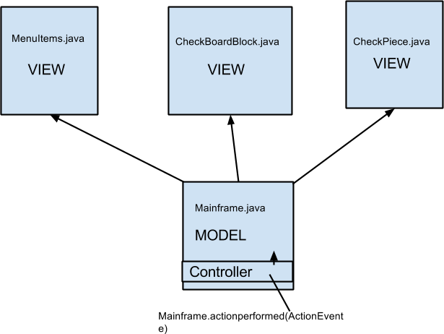

Architectural Design
The checkers game is designed with the MVC structure in mind to differentiate between three varying aspects. The MVC is pattern is set up so there is a clear distinction between the user inputs, the graphical output and the logic. The interaction between the three defines how our program will behave on an abstract level. The model category will hold the set of class with all the business logic to properly operate this program. The model then transfers this logic to the set of classes under the view category, which takes this information and output this information in a graphical format. The controller category has a set of classes that interacts with the user. The set inputs get transferred from controller to model and then out to view for the final result.
The stimuli for this project will be the (standard button, manual button, position, piece colour). These will be all the possible inputs that the user can input. These variables also affect how the program will look and what the program outputs. The set of outputs will the piece and position on the board as well as an error message regarding exceeding 12 pieces. These will be the controlled variables.
Break up components of MVC structure and explain the relationship of the model (i.e how the model interacts with the controller and view etc). Identify the stimuli for the program (i.e position number, piece colour, button push, etc.) and describe the set of all possible outputs as well (i.e. error messages, GUI, etc.). Label these as the monitored and controlled variables and explain why as well. Describe the the model will interact with the controller and and view. Make sure description is specific to the checkers program and ensure that it satisfies all the desired functions of our program.

Decomposition
The decomposition of the program follows the MVC structure. Each category has its own set of classes under each of the three MVC categories. This program consisted of a total of 4 classes. The MenuItems, Mainframe, CheckBoardBlock and CheckPiece. Under the Model category is the Mainframe, which holds all the gaming logic that this game needs. In the View category, the set of classes are {CheckBoardBlock, MenuItems and CheckPiece}. The final category, Controller, which is responsible for all user inputs will be under the Mainframe category. This was design decision made as a logical consequence. For this program the controller first has to manipulate the model which further manipulates the view. Due to this order, we constructed a separate method under the Mainframe class that handles the entire set of user inputs as to distinguish this attribute (controller) from the Mainframe (model).

Module Interface Specifications

MIS 1 - Module: MenuItems.java

Constants: public static final int itemsCount [], public static final string items []

Constructor: Static
- Initializes menu-items

MIS 2 - Module: Mainframe.java
Public class MainFrame implements ActionListener and JPanel

Constructor Mainframe:
- Initializes menu-items

Public void initPieces()
- Initialize both white and block pieces

Public void Initialize()
- Board initialized and pieces on initial positions

Public void initCheckBoardAutomaticly()
- Initialize all pieces to default opening positions

Public void setBoardEnabled(boolean flag)
- make board clickable

Public void initCheckBoardManually()
- let user define positions for pieces manually

Public void putPieceOnBoard(CheckBoardBlock b, String player)
- triggered during manual setup, this puts one piece in the board

Public void reFormatPieceLayer()
- Refresh the pieces according to the piece record

Public int getBlackCountInVector()
- Get black piece on the board

Public int getWhiteCountInVector()
- Get white piece on the board

Public void print()
- prints checker piece for testing
Public void actionPerformed(ActionEvent e)
- detects a clickable event and performs the appropriate operation

MIS 3 - Module: CheckBoardBlock
Types: Strings, Graphics

public CheckBoardBlock(String color, String position)
- position and colour values are initialized by this constructor

public void paint(Graphics g)
- paints each block either red or white

MIS 4 - Module: CheckPiece

public CheckPiece(String player, String position)
- Position and colour values are initialized

public void paintComponent(Graphics g)
- Paints the individual pieces

public void paintBorder(Graphics g)
- Paints the border

3.3. Design Rationale

The MVC pattern was the ideal decision for this application as it yielded itself perfectly for break down of the checkers game. The rules and logic of the game can be placed in the model category while the graphics could fall under view and user inputs under the controller category. The benefit of this setup allow for easier future manipulation of the source code. By separating into three categories, one can effectively manage the internal components of each class while worrying less about the interaction between them. This design pattern is best practiced for graphical applications. MVc was the natural choice for this application
SPECIFICATIONS
Tabular expressions
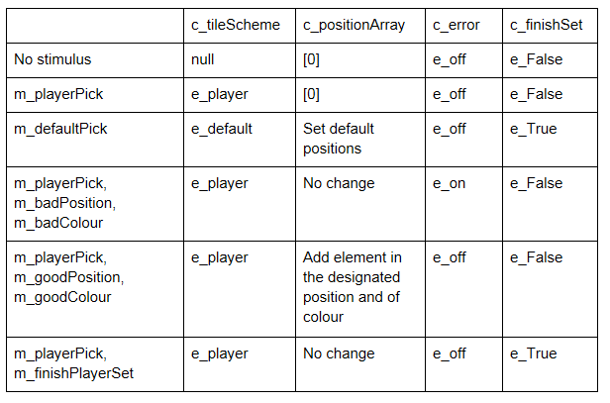
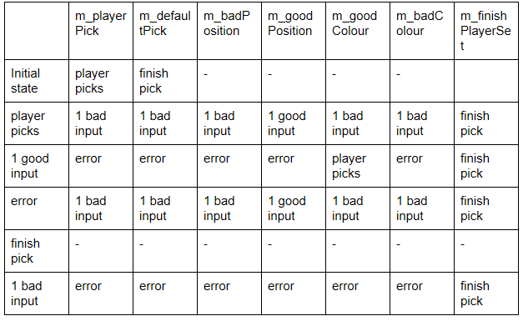

Testing and Maintaining

Test Case: |  | Expected Results | Actual Results
1) | Click to set a checker on already exists position | No response | No response
2) | Click the very right corner of chessboard | No response | No response
3) | Click a valid position | The application should set piece on the board. | The application should set piece on the board.

